4a. DECISION TREE CLASSIFICATION ON LOAD_IRIS DATASET

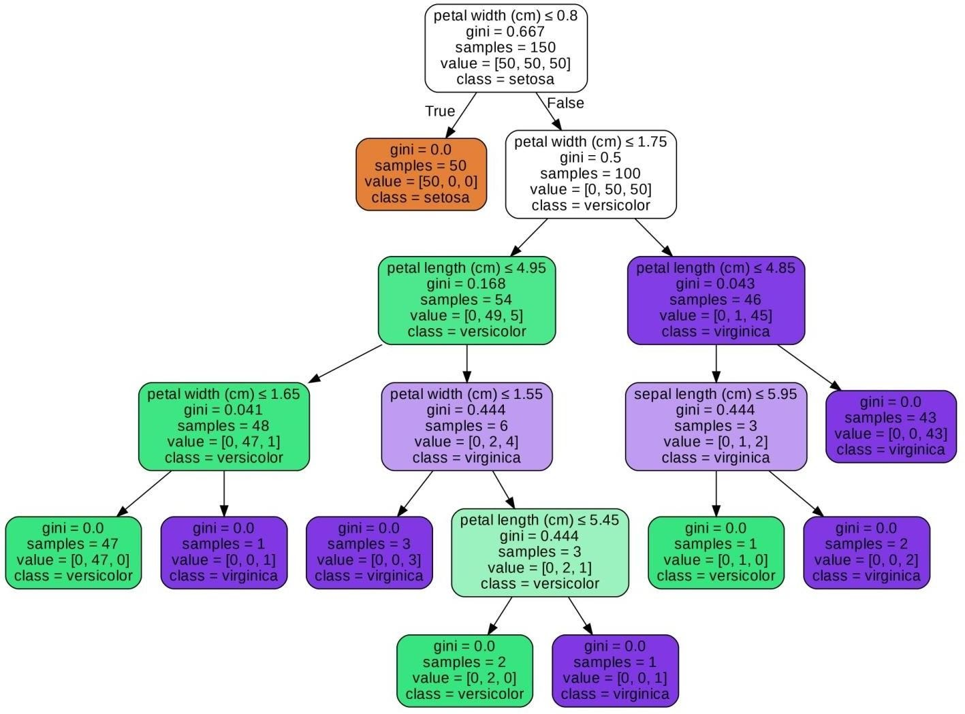

4b. DECISION TREE CLASSIFICATION ON HEART DATASET

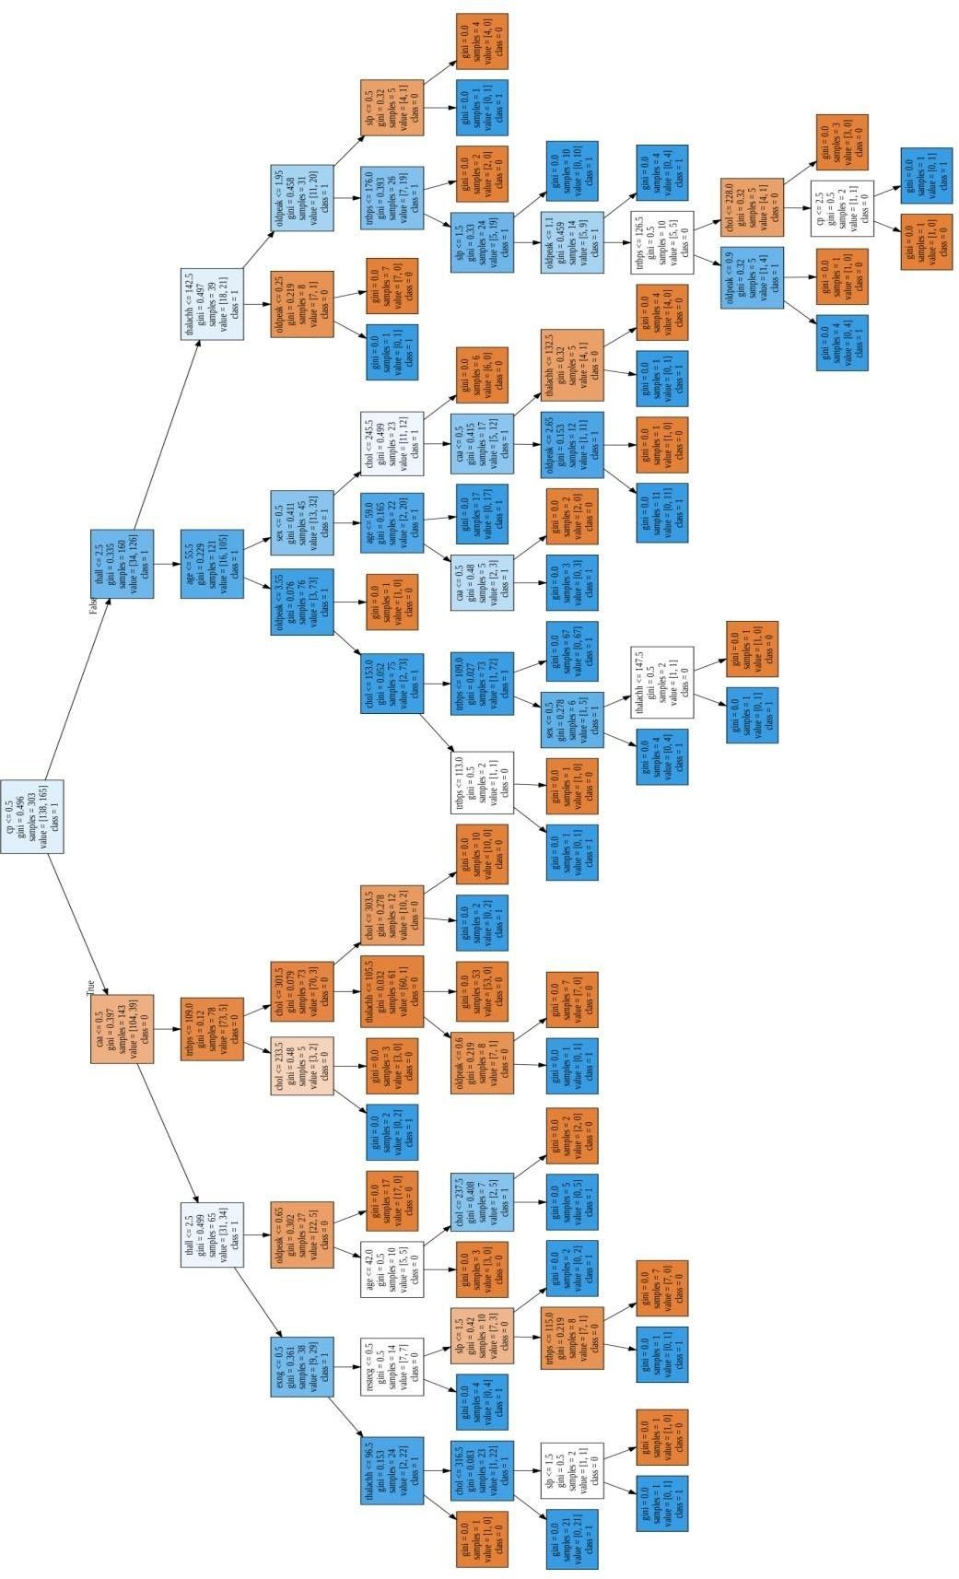

4c. DECISION TREE CLASSIFICATION ON LOAD_WINE DATASET

